Names: Ishimwe Thierry

Student I.D: 23756

WEB-TECHNOLOGY FINAL PROJECT

**[ PART 5]**

User Documentation: Student Conduct System

Welcome to the Student Conduct System user documentation. This guide will provide you with an overview of the application, including login credentials, navigation instructions, and available features and functionality.

Login Credentials:

URL: [Insert application URL]

Username: [Provide username]

Password: [Provide password]

Application Navigation:

Once you have logged into the Student Conduct System, you will encounter the following key sections and navigation elements:

a. Dashboard:

The dashboard provides an overview of recent conduct incidents, notifications, and important announcements.

b. Conduct Incidents:

This section allows you to record and manage conduct incidents for students.

To add a new conduct incident:

Click on "Conduct Incidents" in the main menu.

Select the student from the list or search for a specific student.

Click on the "Add Incident" button and fill in the incident details (date, category, description, etc.).

Save the incident record.

c. Parent Communication:

This section enables you to send messages and notifications to parents regarding their children's behavior in school.

To send a message to a parent:

Navigate to the "Parent Communication" section.

Select the parent from the list or search for a specific parent.

Compose your message in the provided text area.

Click the "Send" button to deliver the message.

d. Reports:

This section provides access to reports and analytics related to student conduct incidents.

You can generate reports based on specific criteria such as date range, student, or conduct category.

e. Account Settings:

In the account settings section, you can manage your personal information, change your password, and update notification preferences.

Additional Features and Functionality:

Search Functionality:

Throughout the application, you will find search capabilities to quickly locate students, parents, or conduct incidents.

Look for a search bar or filters to refine your search criteria.

Notifications and Announcements:

The system will send you notifications and announcements regarding important updates, new conduct incidents, and messages from parents.

Access Control and Security:

The Student Conduct System has role-based access control, ensuring that only authorized personnel can access sensitive information.

Please ensure you keep your login credentials secure and do not share them with unauthorized individuals.

Support and Assistance:

If you encounter any difficulties or have questions regarding the Student Conduct System, please contact the system administrator or the technical support team. They will be available to assist you and address any concerns you may have.

Thank you for using the Student Conduct System!

**Screenshots/ workflow**

* 1. **The system shall provide signup system for new students to register new accounts.**

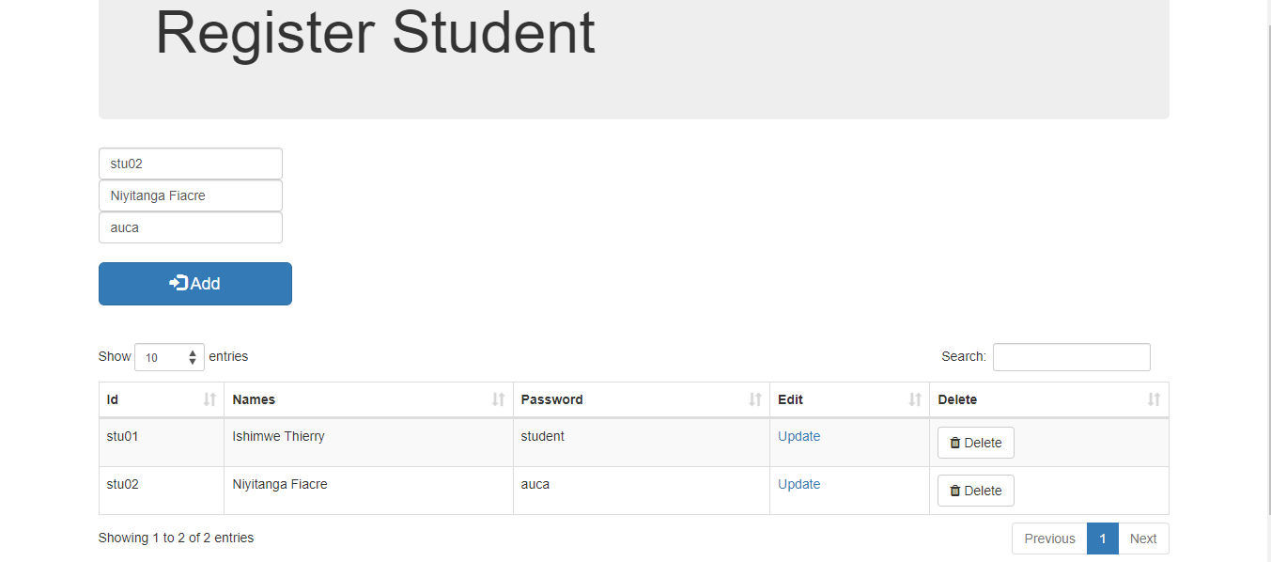

* 1. **The system must provide login system for returning university students with accounts.**

**Login form**

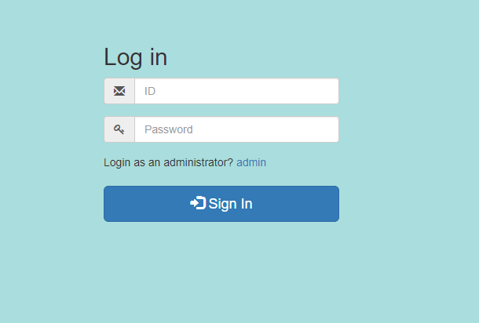

**After Logging into Student Account**

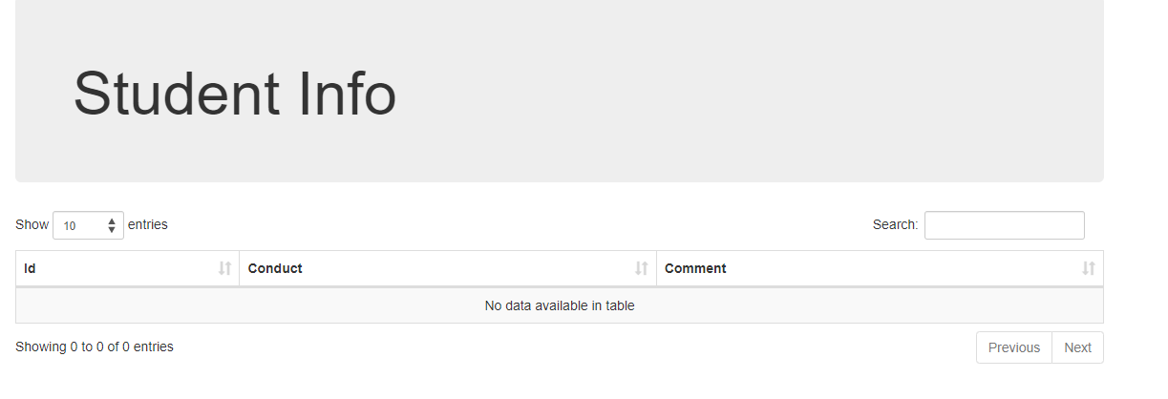

* 1. **The system shall provide a login system for the admin where they shall add,**

**delete, view students to the database.**



After inserting I clicked Display to see if it was inserted

1. I can also delete using the Delete Button (I deleted the first record for demonstration)



* 1. **The system shall provide the admin the capacity to view all students and to search for any student and admin can add conduct of students and comments about student’s behaviors.**

Once logged in as admin you click on View submission

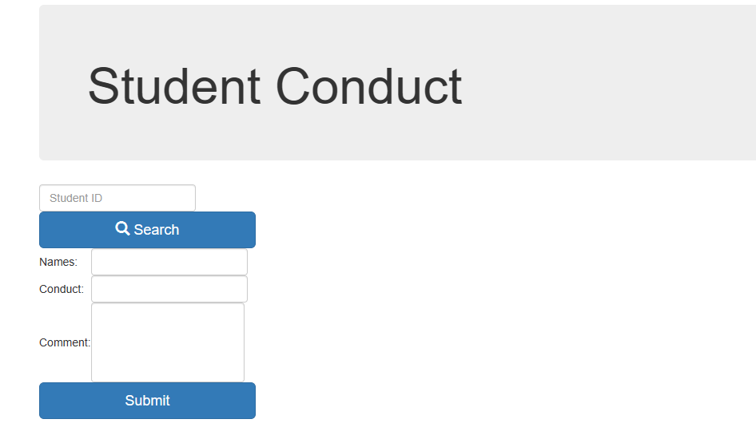

Then parents or students can view all applications about students submitted by the admin or school:

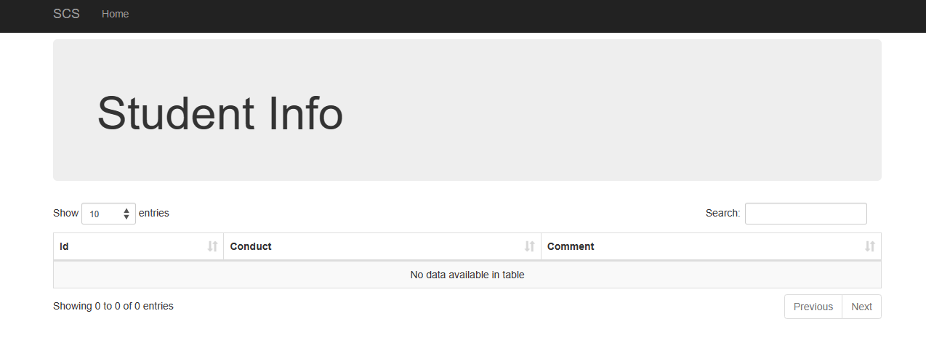

**6. The system shall provide a home option to display available fields to website visitors.**

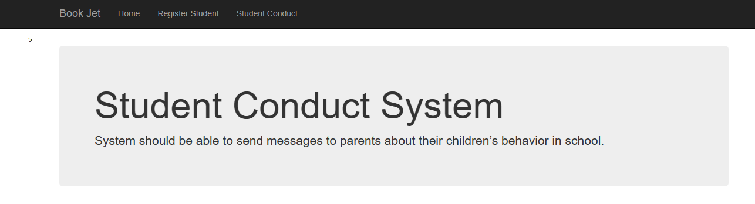

**[ PART 2]**

Using MVC architecture implement each feature, and for each feature provide a screenshots demonstrating the implementation of Model, View and Controller components. Use Ajax at least in sending one request.

Side Note: Before running the project please add the following jars: PostgreSQL and boots faces into the library in NetBeans (To avoid exceptions because we need to import them)

I added them inside the folder so that you can find them

side by side with my project **23756_Ishimwe_Thierry_WebTechProject**

**[ PART 3 ]**

**Implement at least 2 non-functional (non-domain specific) features of your webapplication.**

1. Security: Students must have valid credentials to be authenticated.

Here if I type a wrong password it will not allow to get into the account no matter how many tries

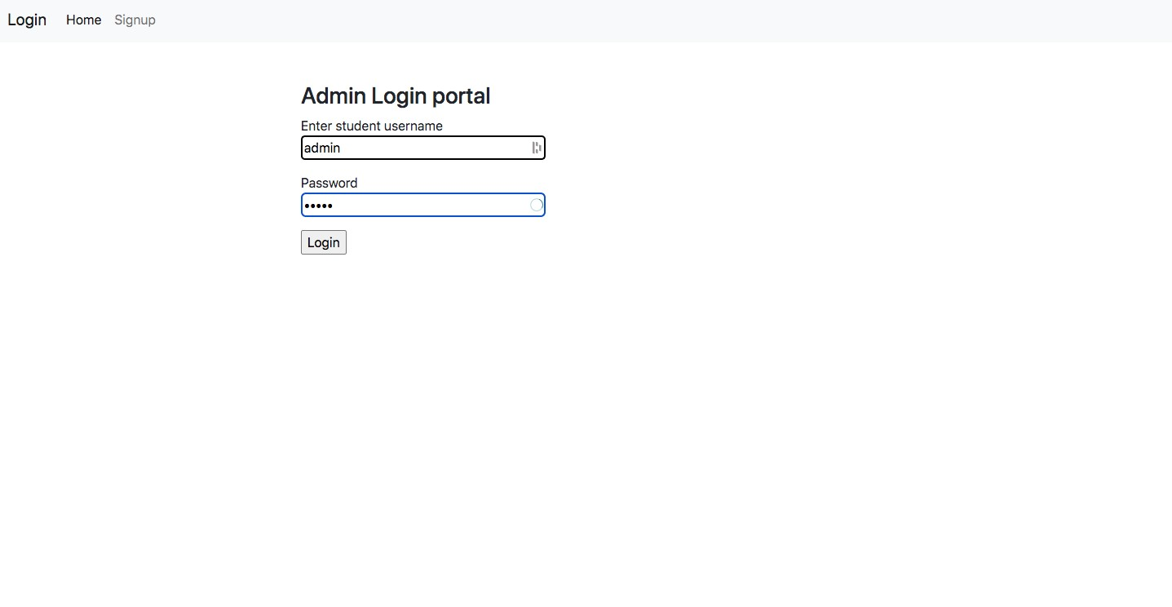

There is also captcha verification for added security

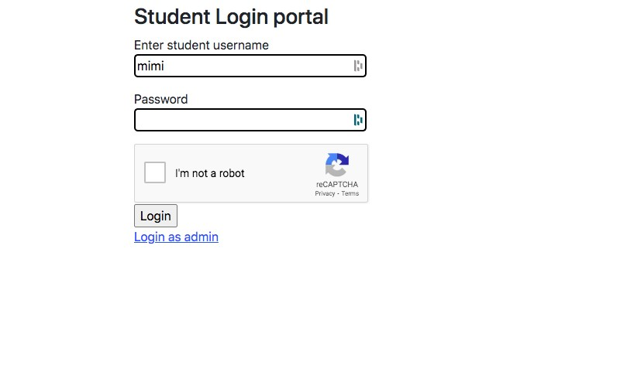

1. Responsive UI: The web application is responsive to smaller screens
   1. The navigation bar collapse with hamburger menu

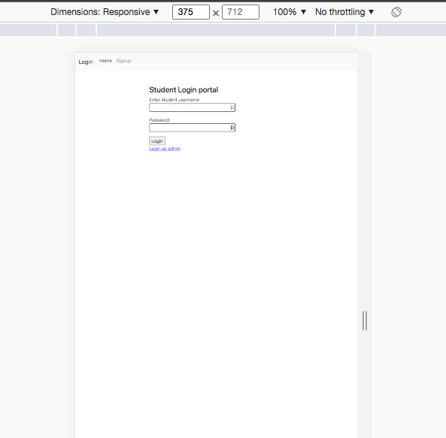



On the login side of both returning students and admin.

Firstly I registered

Implementation in the project:

Inside my Login Bean (Login.java) class is where the validation is so that you must select the reCaptcha before logging in